

SCHOOL OF COMPUTER ENGINEERING AND INFORMATION SYSTEM

DEPARTMENT: SOFTWARE ENGINEERING

NAME: VIGNESHWARAN T

REG NO: 23MIS0587

COURSE NAME: Agile Development Process and
Devops Lab

COURSE CODE: ISWE406P

SLOT: L3 + L4

DIGITAL ASSIGNMENT –III
(Maven)

1.Create a Maven Project in Git

• Create a new Git repository
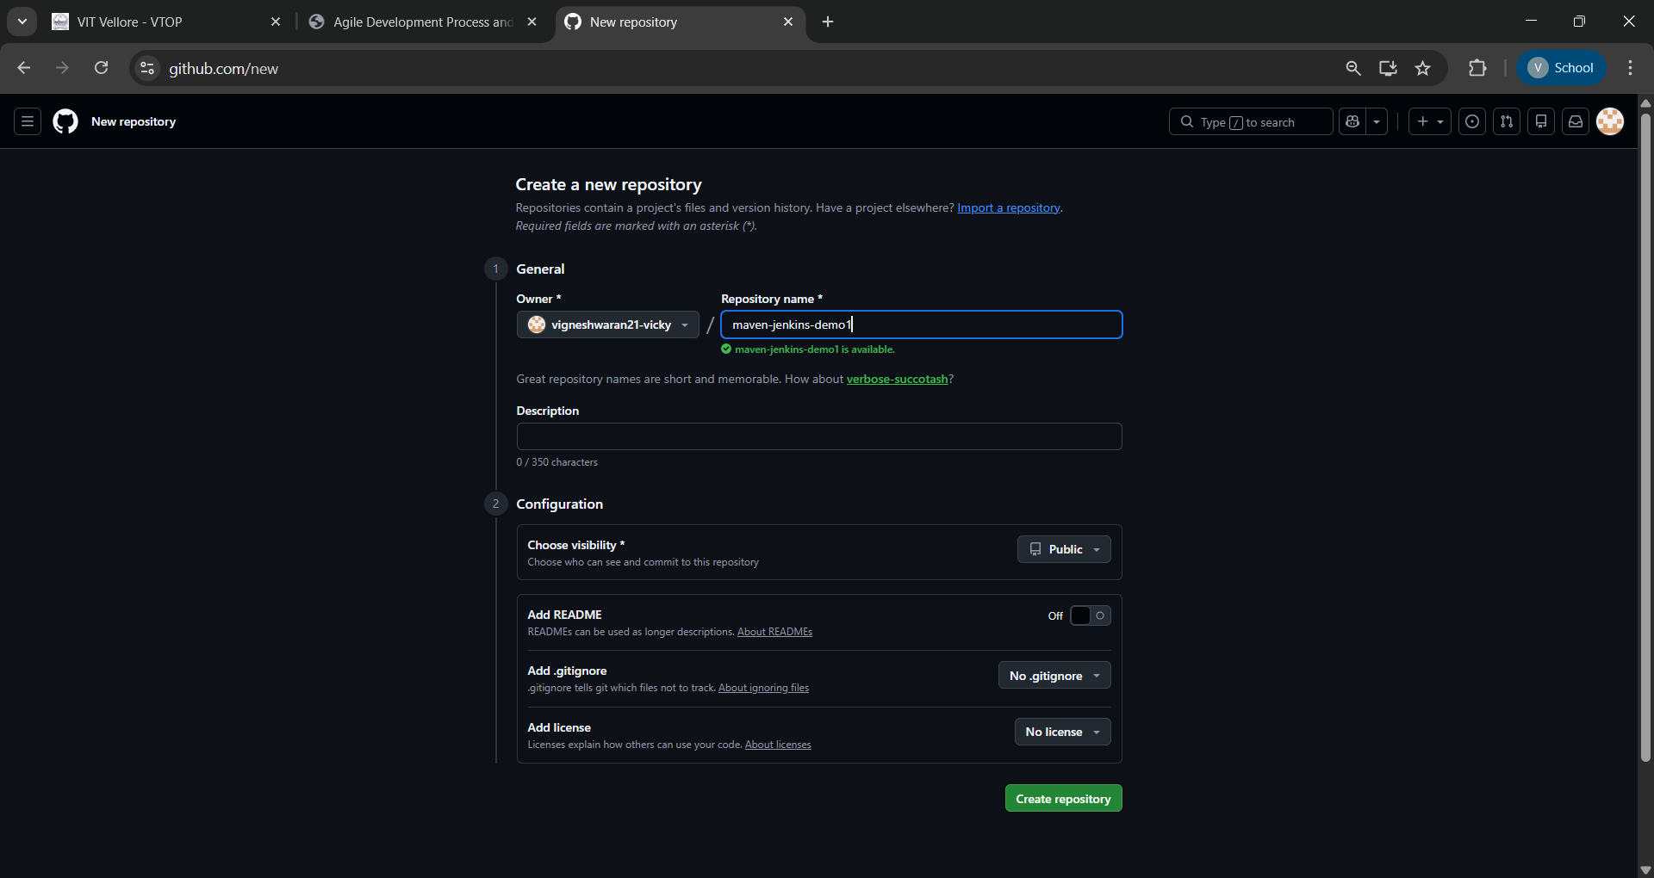
• Create a simple Maven project structure manually, including the following files and folders:
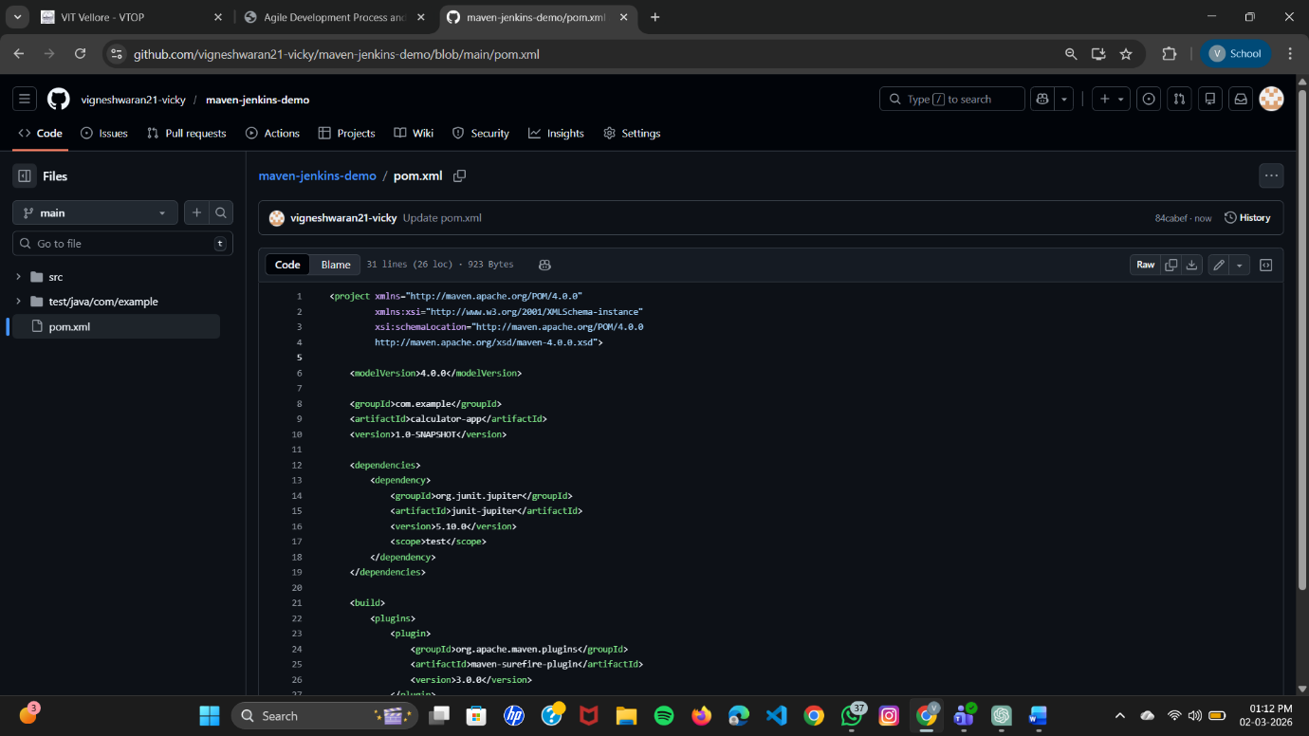
- pom.xml
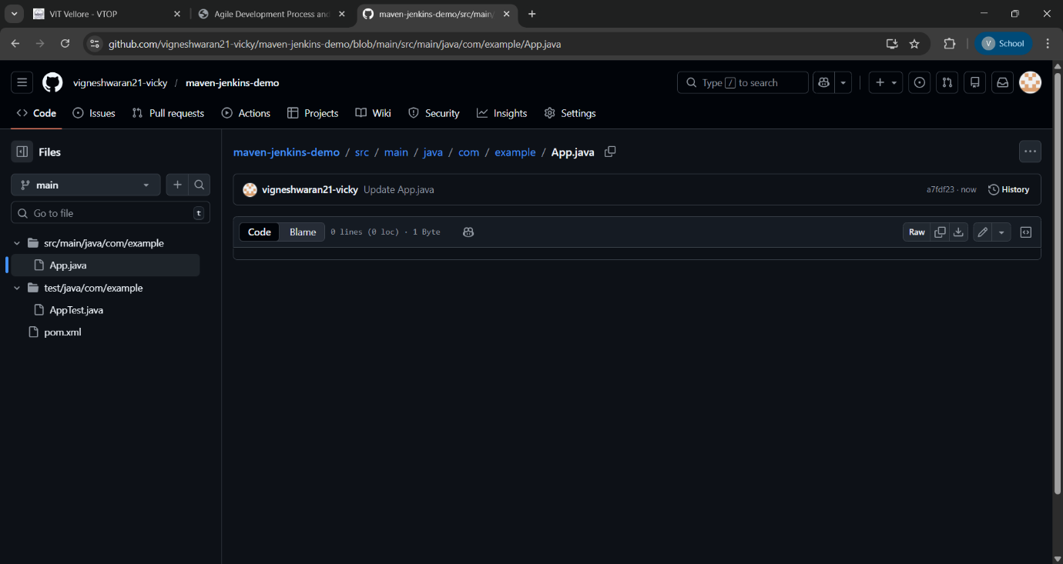
- src/main/java/com/example/App.java

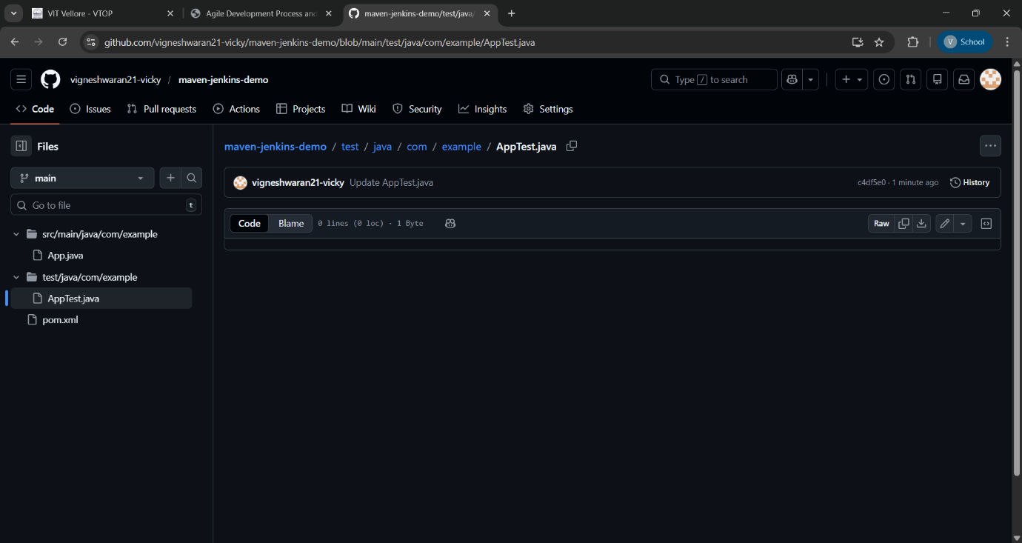
- src/test/java/com/example/AppTest.java

2. Implement the Java Program
• Write a simple Java program in App.java under your newly created Git repository for any one of the following scenarios:
o Student Grade Calculator
o Bank Account Management System
o Employee Salary Calculator
o Library Book Management System
o Simple Calculator Application

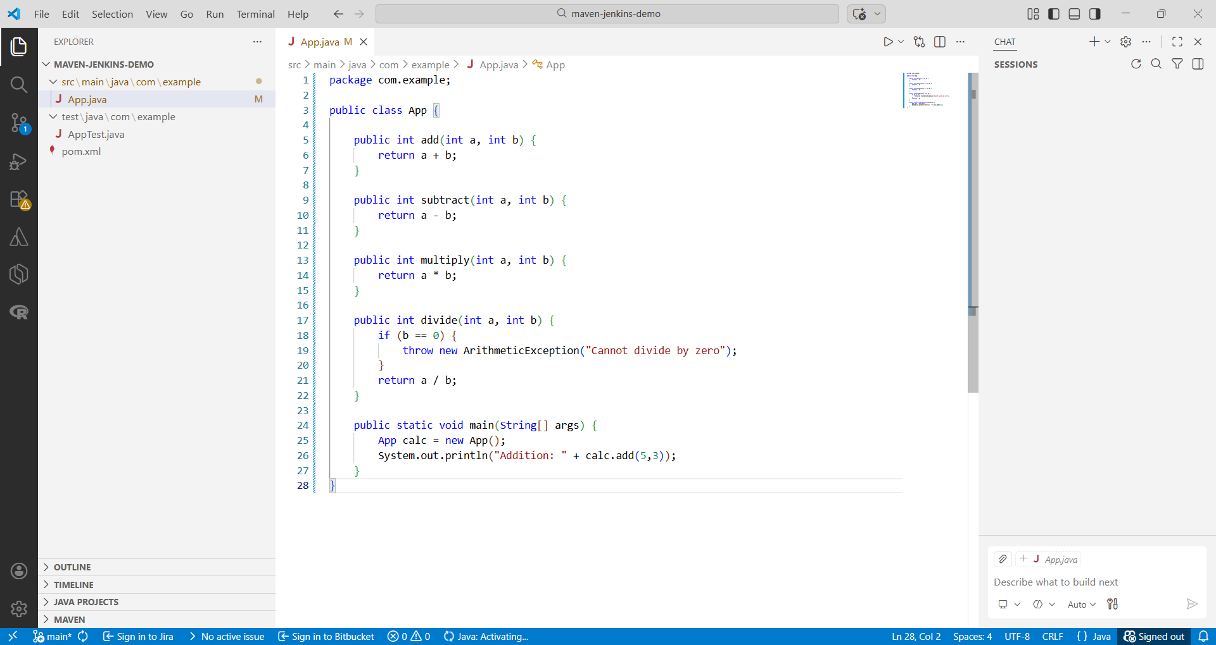

• Write a corresponding unit test in AppTest.java.

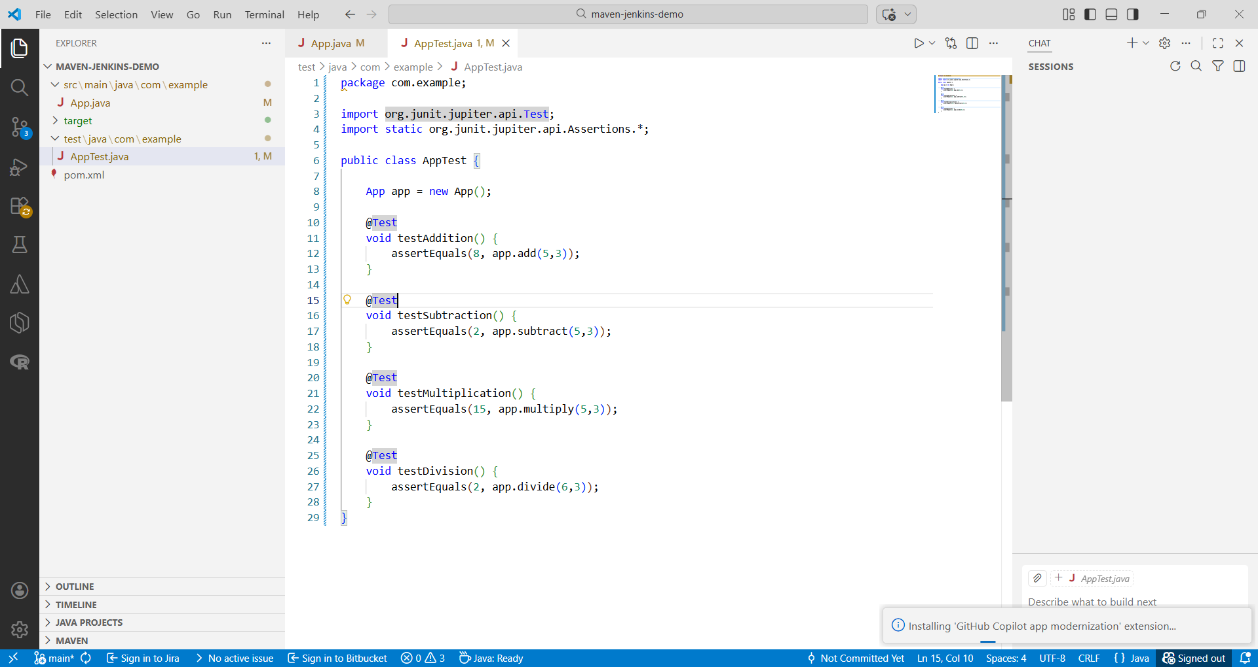
3. Push and Clone the Repository

• Clone the repository using Visual Studio Code.

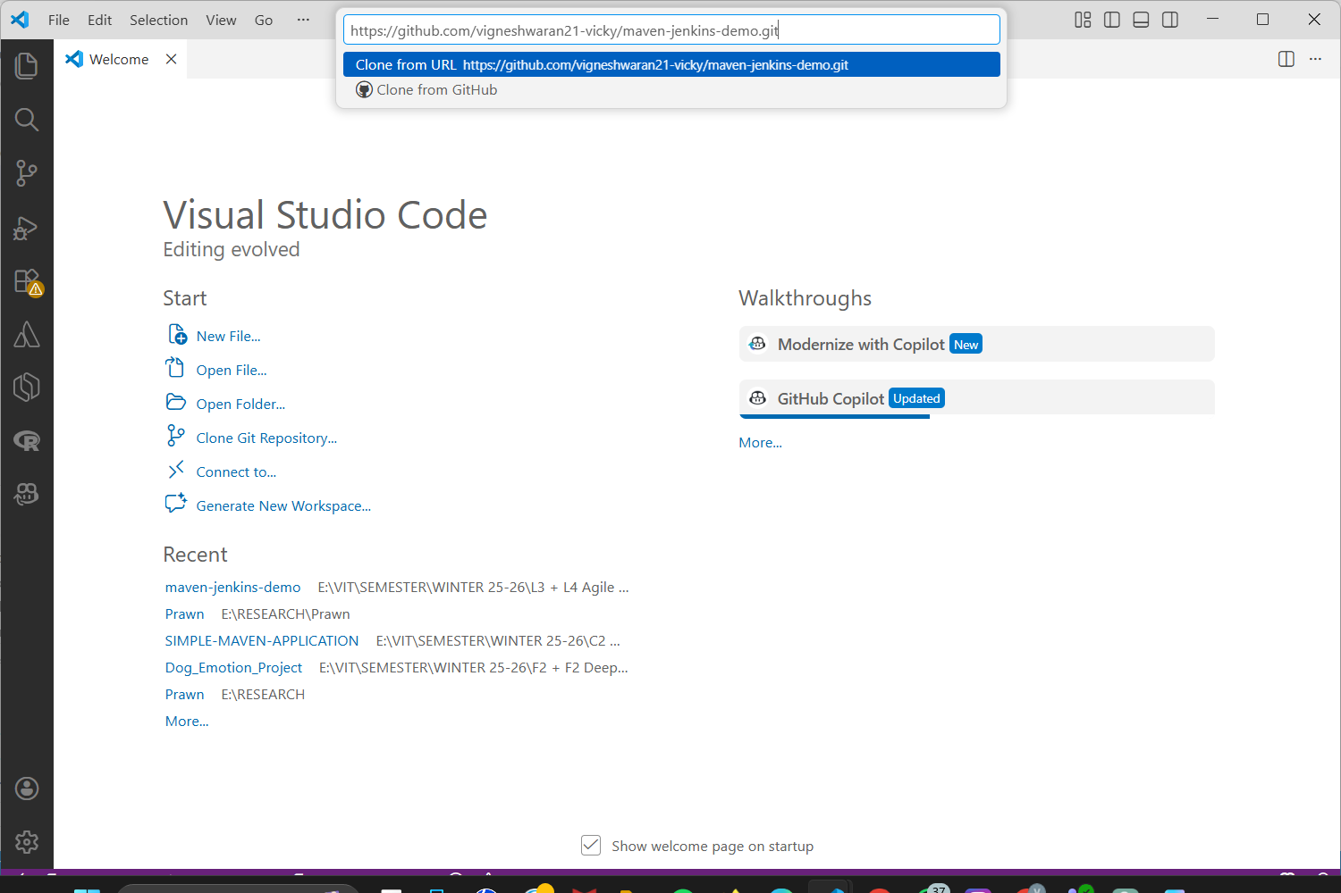

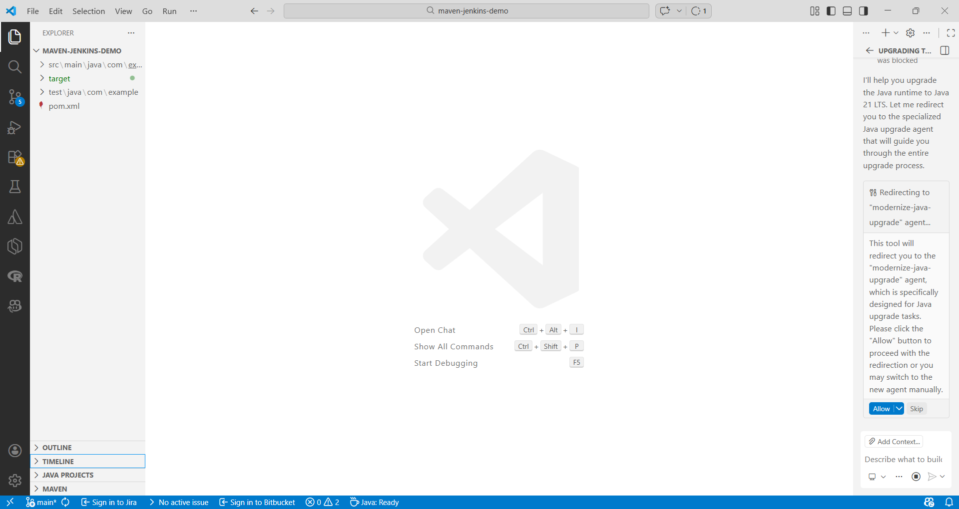

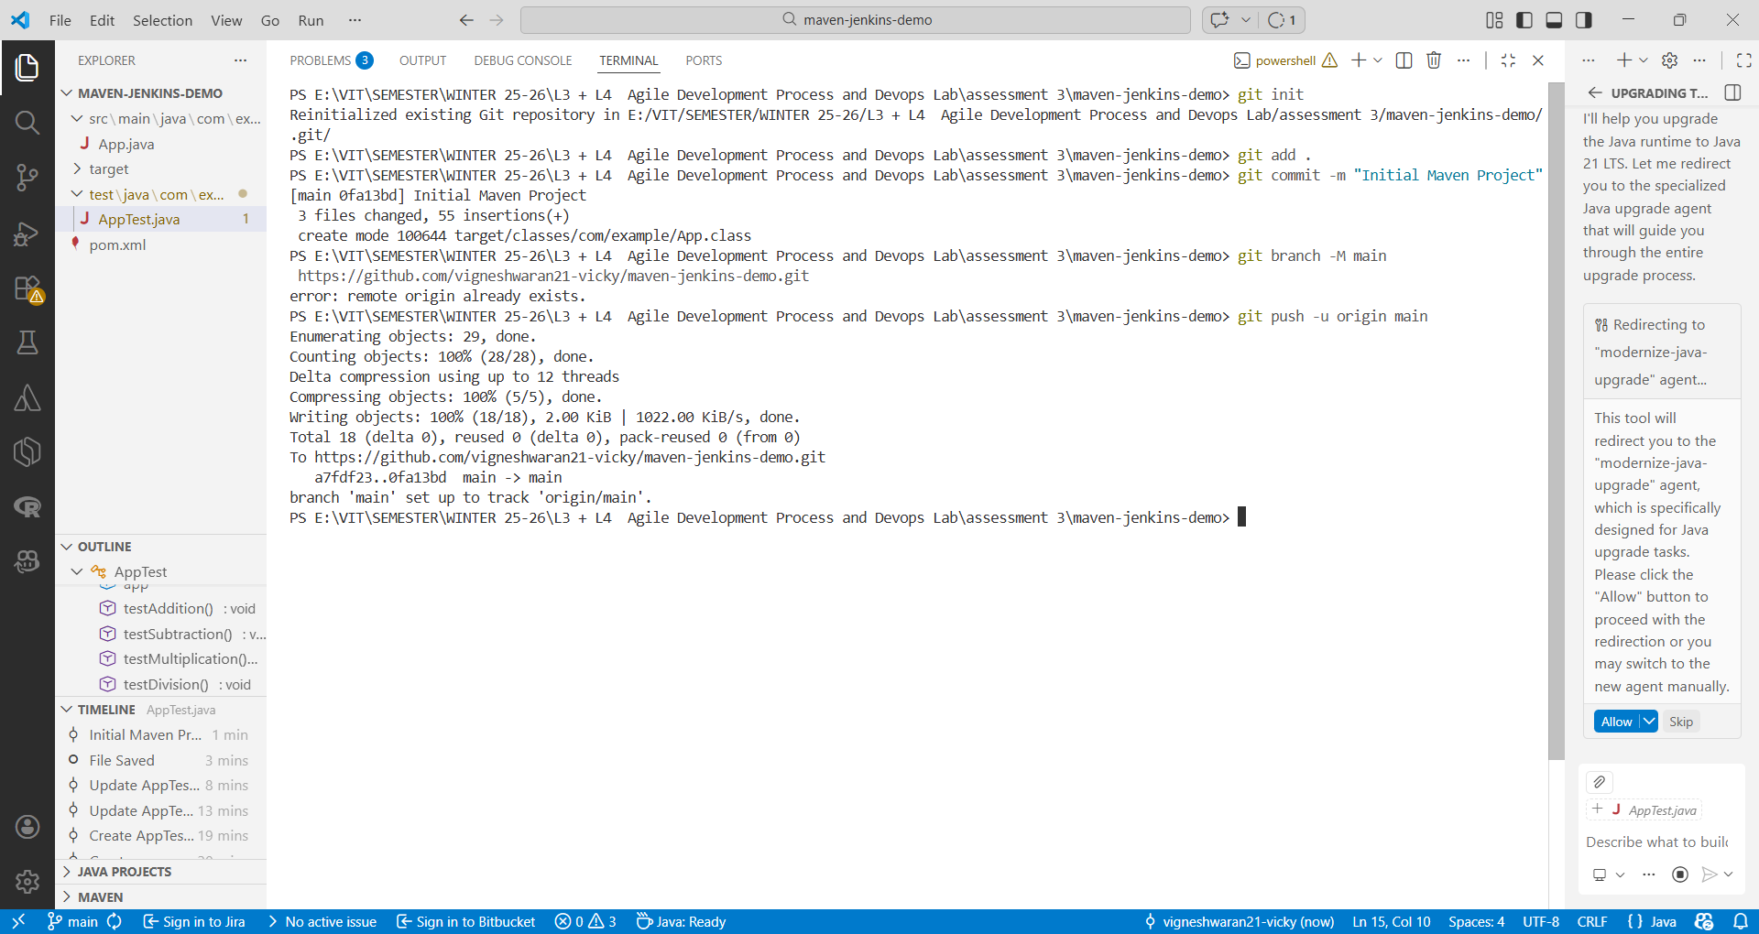

• Verify the project structure.

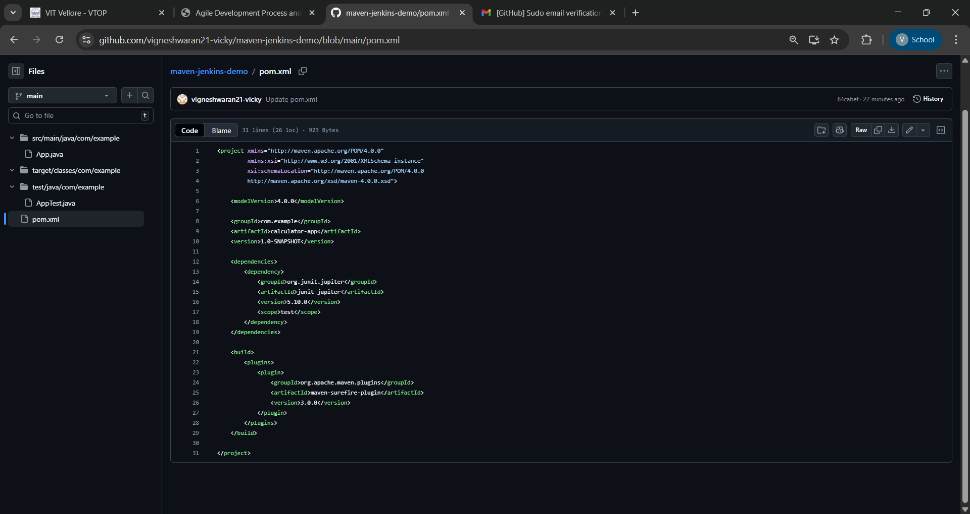

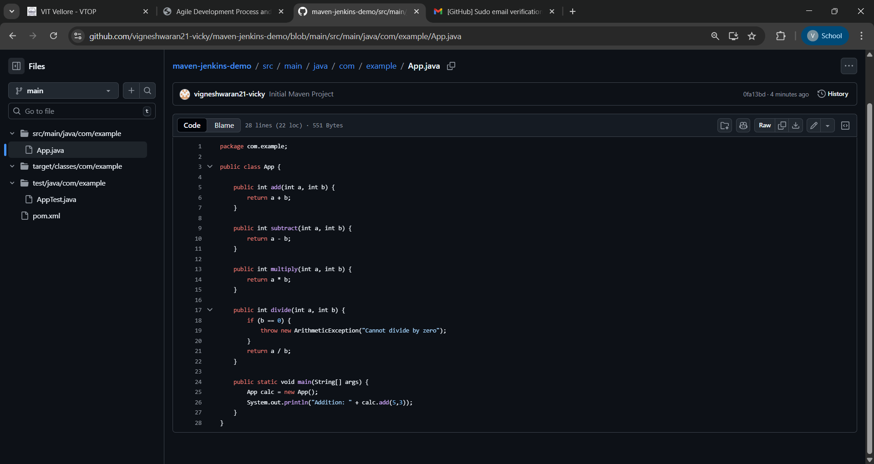

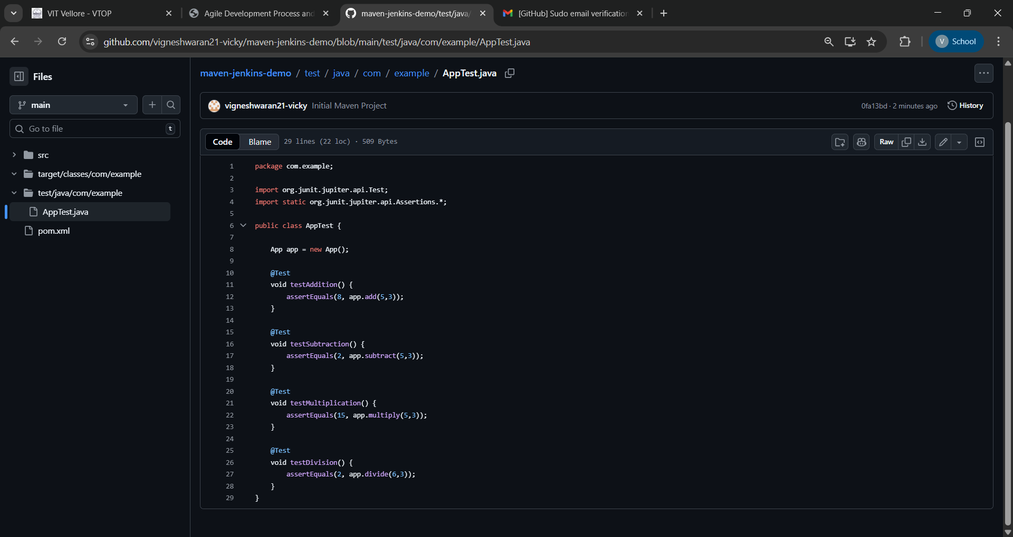

4. Build the Maven Project
• Use Maven commands in Visual Studio Code terminal to:
- Compile the project

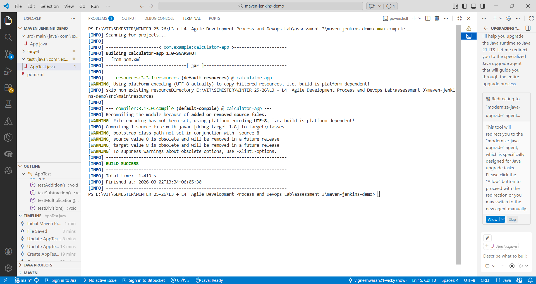

- Run tests

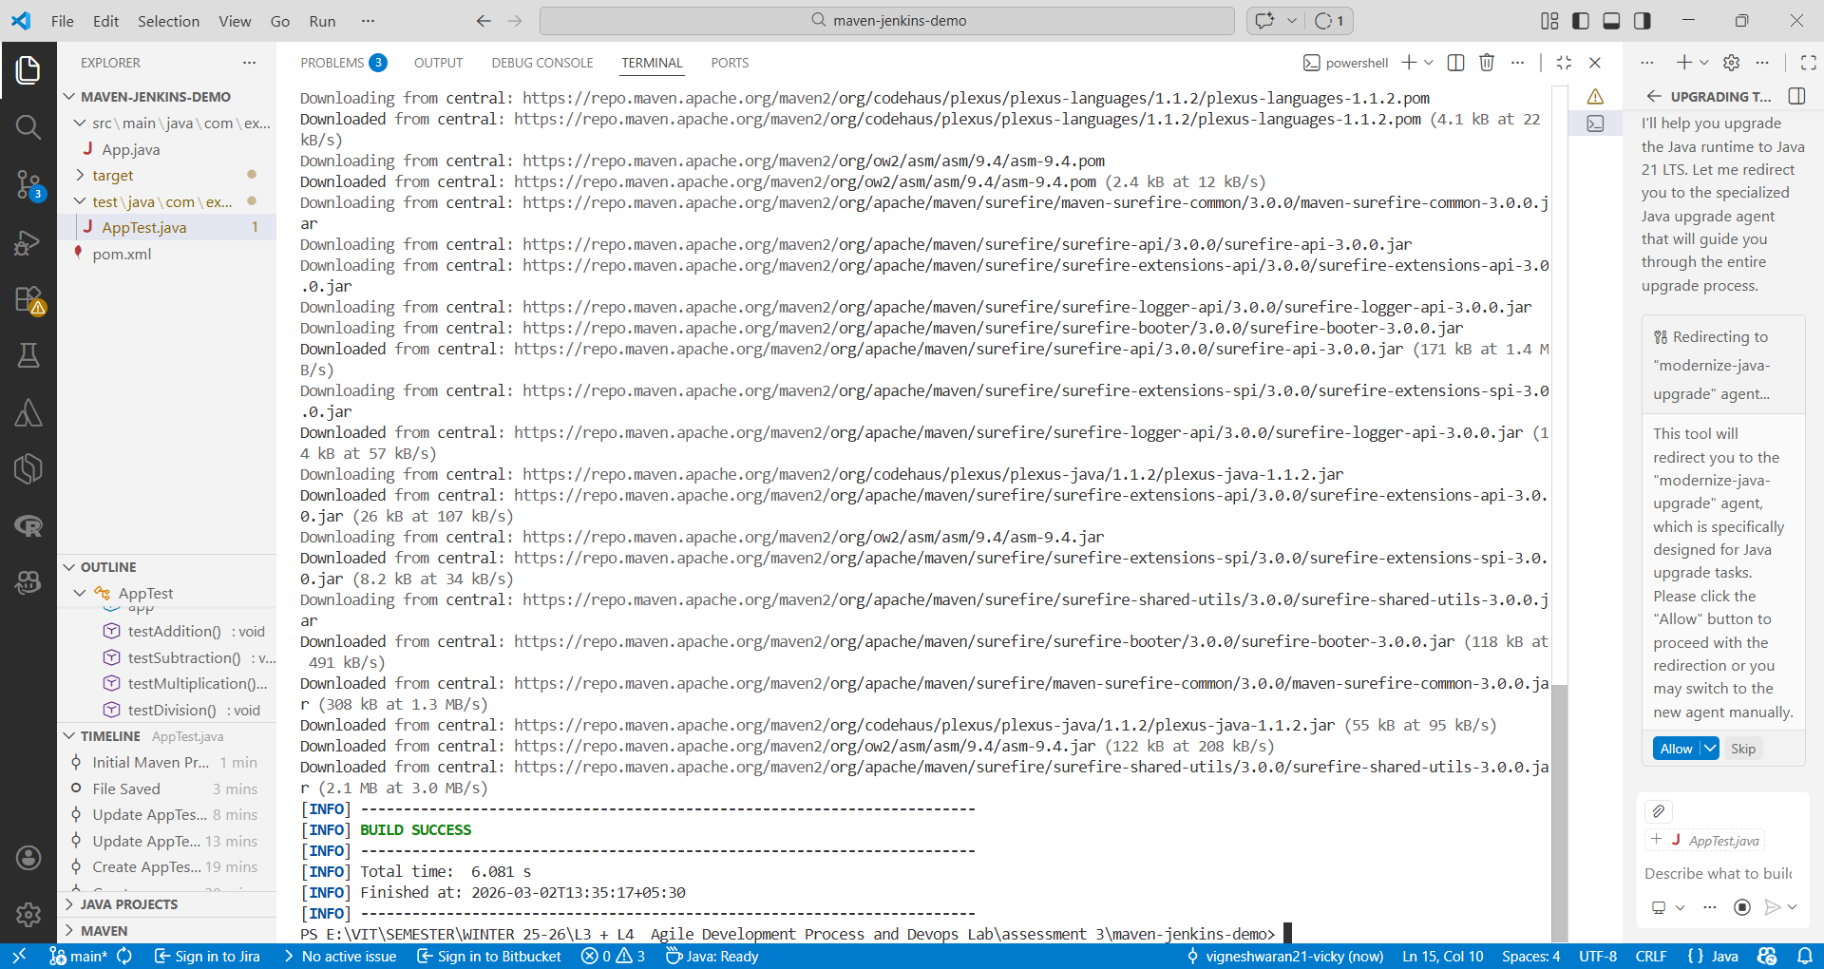

- Build the project (mvn clean install)

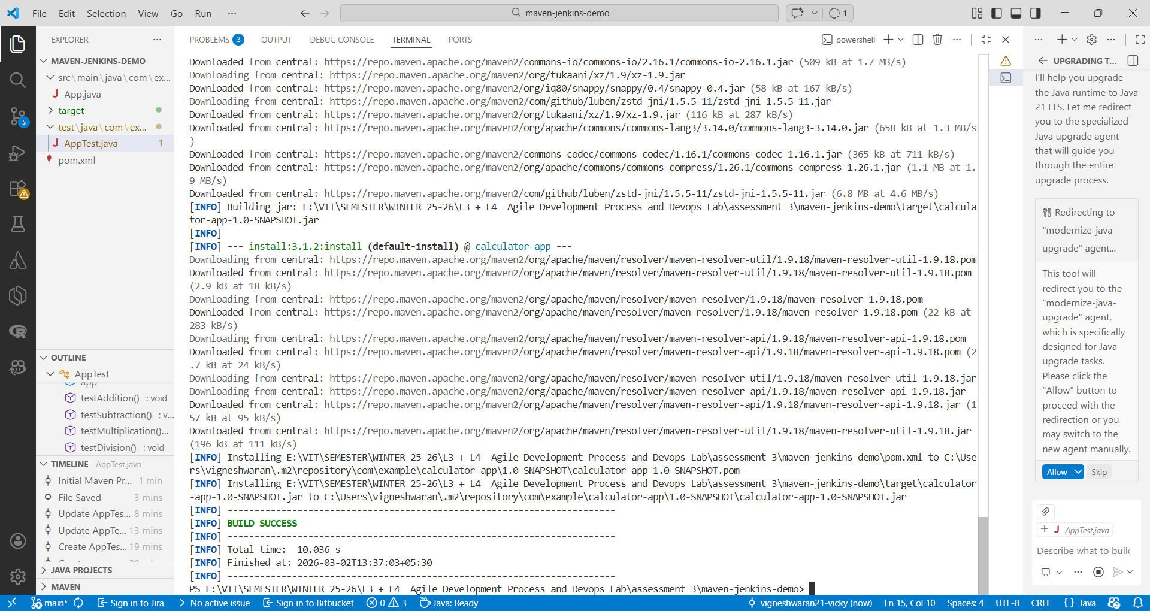

5. Create and Run Jenkins Pipeline
• Create a new Pipeline project in Jenkins.

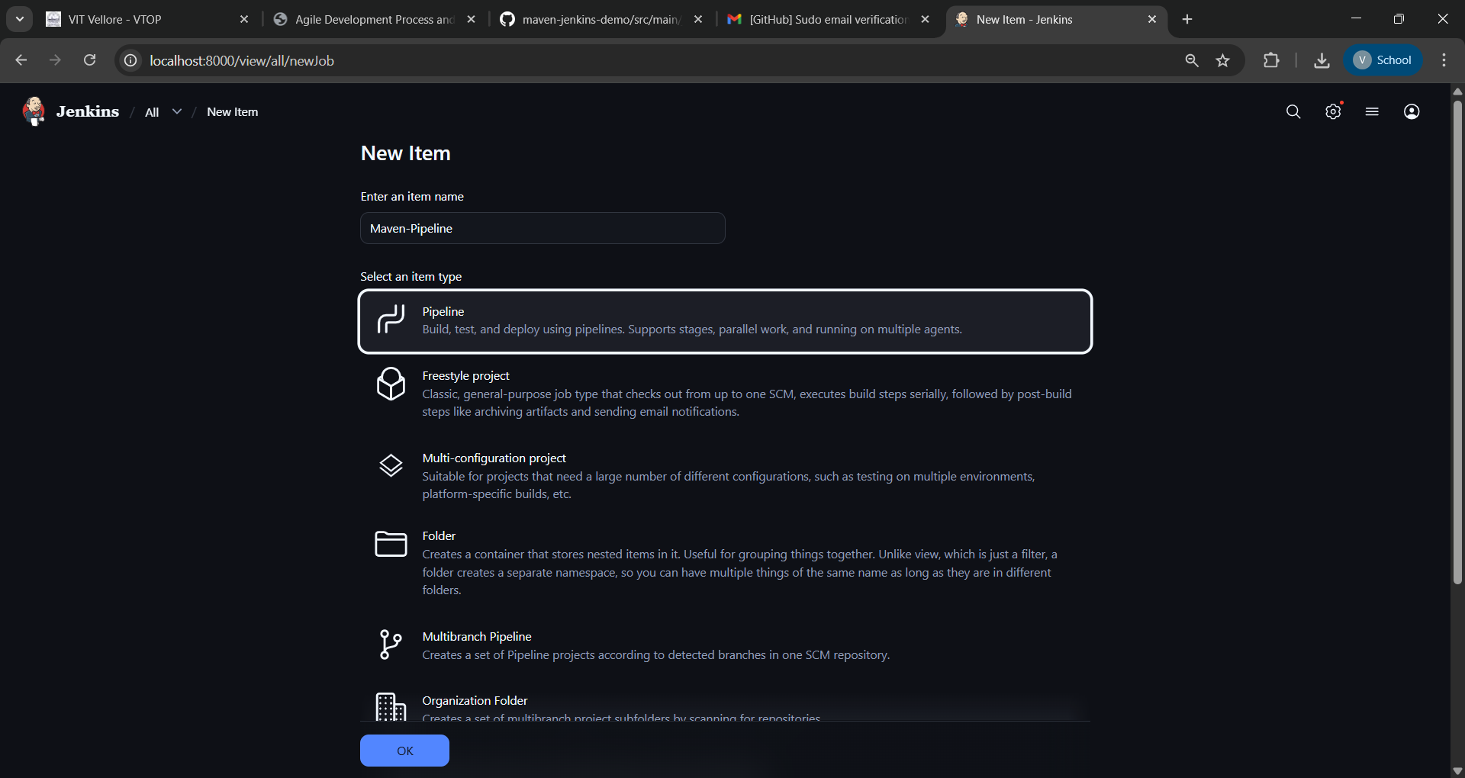

• Create a pipeline script

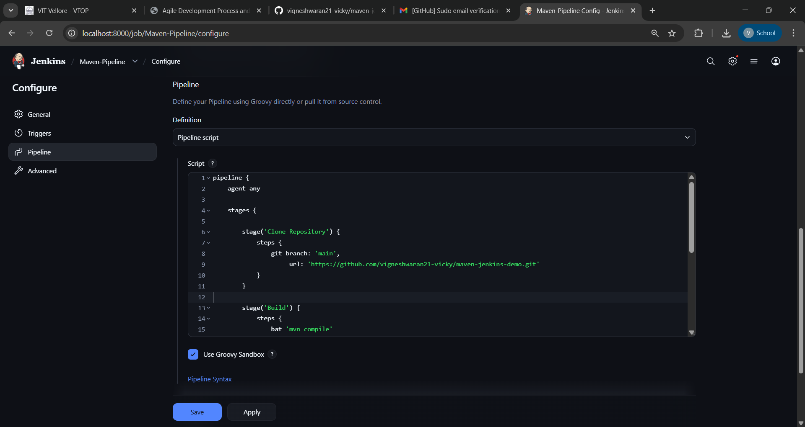

• Execute the pipeline and verify successful build completion.

